 

**SRI SIDDHARTHA INSTITUTE OF TECHNOLOGY**

**(A Constituent college of Sri Siddhartha Academy of Higher Education)**

**Department of Computer Science & Engineering**

**Report on “Mini Project on Solar Power Plant”**

***Submitted by :***

**Srinidhi B (17CS104)**

**Rohan T S (17CS084)**

**UNDER THE GUIDANCE OF:**

**Madumala G Sahana**

Assistant Professor Assistant Professor

Dept. of C.S.E . Dept. of C.S.E.

S.S.I.T,Tumkur S.S.I.T,Tumkur

***Certificate***

This is to certify that the course ***CG mini project on “SOLAR POWER PLANT” (CS6L01)*** has been completed successfully in sixth semester of Bachelor of Engineering in Computer Science and Engineering of Sri Siddhartha Academy of Higher Education during the academic year 2019-20.

**UNDER THE GUIDANCE OF:**

**Madumala G Sahana**

Assistant Professor Assistant Professor

Dept. of C.S.E . Dept. of C.S.E.

S.S.I.T,Tumkur S.S.I.T,Tumkur

**Dr.M.Siddappa Ph.D.**

Professor & Head,

Dept. of C.S.E.

S.S.I.T., Tumkur

Examiner 1 Name: Examiner 2 Name:

Signature: Signature:

**MINI PROJECT ON**

**‘’ SOLAR POWER PLANT”**

**CONTENTS**

|  |  |  |
| --- | --- | --- |
| **SL.NO** | **particulars** | **PAGE.NO** |
| **1** | Abstract | 5 |
| **2** | System Specifications | 6 |
| **3** | Introduction to openGL | 7 |
| **5** | Implementation | 9 |
| **6** | Interaction | 11 |
| **7** | Source Code | 12 |
| **8** | Output | 36 |
| **9** | Conclusion | 38 |
| **10** | Bibliography | 39 |
|  |  |  |

**Abstract**

* Main aim of this Mini Project is to illustrate the concepts of working of a Satellite in OpenGL.
* A S**atellite** is an object which has been placed into [orbit](http://en.wikipedia.org/wiki/Orbit) by human endeavor. Such objects are sometimes called **artificial satellites** to distinguish them from [natural satellites](http://en.wikipedia.org/wiki/Natural_satellite) such as the [Moon](http://en.wikipedia.org/wiki/Moon)
* Satellites are used for a large number of purposes. Common types include military and civilian Earth observation satellites, [communications satellites](http://en.wikipedia.org/wiki/Communications_satellite), navigation satellites, weather satellites, and research satellites.
* This pushed the entire network into a 'congestion collapse' where most packets were lost and the resultant throughput was negligible.
* We have used input devices like mouse and key board to interact with program.
* We have also used SolidCube for forming a complete network setup which help to understand concept of Congestion Control very well.
* To differentiate between objects we have used different colors for different objects.
* We have added menu which makes the program more interactive.
* In this project we have used a small SolidCube to represent a data, which travels as data transfer from source to destination.
* We have used font family for indicating the name of objects as we can see in this project.

**System specifications**

* **SOFTWARE REQUIREMENTS :**
* MICROSOFT VISUAL C++
* OPENGL
* **HARDWARE REQUIREMENT :**
* GRAPHICS SYSTEM,
* Pentium P4 with 256 of Ram(Min)

**Introduction to openGL**

As a software interface for graphics hardware, OpenGL's main purpose is to render two- and three-dimensional objects into a frame buffer.

These objects are described as sequences of vertices or pixels.

OpenGL performs several processing steps on this data to convert it to pixels to form the final desired image in the frame buffer.

## OpenGL Fundamentals

This section explains some of the concepts inherent in OpenGL.

### Primitives and Commands

OpenGL draws primitives—points, line segments, or polygons—subject to several selectable modes.

You can control modes independently of each other; that is, setting one mode doesn't affect whether other modes are set .Primitives are specified, modes are set, and other OpenGL operations are described by issuing commands in the form of function calls.

Primitives are defined by a group of one or more vertices. A vertex defines a point, an endpoint of a line, or a corner of a polygon where two edges meet. Data is associated with a vertex, and each vertex and its associated data are processed independently, in order, and in the same way. The type of clipping depends on which primitive the group of vertices represents.

Commands are always processed in the order in which they are received, although there may be an indeterminate delay before a command takes effect. This means that each primitive is drawn completely before any subsequent command takes effect. It also means that state-querying commands return data that's consistent with complete execution of all previously issued OpenGL commands.

## Basic OpenGL Operation

The figure shown below gives an abstract, high-level block diagram of how OpenGL processes data. In the diagram, commands enter from the left and proceed through what can be thought of as a processing pipeline. Some commands specify geometric objects to be drawn, and others control how the objects are handled during the various processing stages.

**Figure . OpenGL Block Diagram**

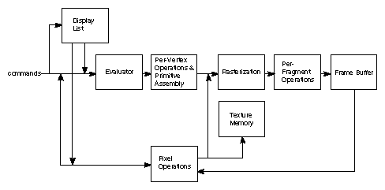

As shown by the first block in the diagram, rather than having all commands proceed immediately through the pipeline, you can choose to accumulate some of them in a display list for processing at a later time.

Rasterization produces a series of frame buffer addresses and associated values using a two-dimensional description of a point, line segment, or polygon.

Each fragment so produced is fed into the last stage,

per-fragment operations, which performs the final operations on the data before it's stored as pixels in the frame buffer. These operations include conditional updates to the frame buffer based on incoming and previously stored z-value s (for z-buffering) and blending of incoming pixel colors with stored colors, as well as masking and other logical operations on pixel values.

All elements of OpenGL state, including the contents of the texture memory and even of the frame buffer, can be obtained by an OpenGL application.

**Implementation**

This program is implemented using various openGL functions which are

shown below.

**Various functions used in this program.**

* glutInit() : interaction between the windowing system and OPENGL is initiated
* glutInitDisplayMode() : used when double buffering is required and depth information is required
* glutCreateWindow() : this opens the OPENGL window and displays the title at top of the window
* glutInitWindowSize() : specifies the size of the window
* glutInitWindowPosition() : specifies the position of the window in screen co-ordinates
* glutKeyboardFunc() : handles normal ascii symbols
* glutSpecialFunc() : handles special keyboard keys
* glutReshapeFunc() : sets up the callback function for reshaping the window
* glutIdleFunc() : this handles the processing of the background
* glutDisplayFunc() : this handles redrawing of the window
* glutMainLoop() : this starts the main loop, it never returns
* glViewport() : used to set up the viewport
* glVertex3fv() : used to set up the points or vertices in three dimensions
* glColor3fv() : used to render color to faces
* glFlush() : used to flush the pipeline
* glutPostRedisplay() : used to trigger an automatic redrawal of the object
* glMatrixMode() : used to set up the required mode of the matrix
* glLoadIdentity() : used to load or initialize to the identity matrix
* glTranslatef() : used to translate or move the rotation centre from one point to another in three dimensions
* glRotatef() : used to rotate an object through a specified rotation angle

**Interaction with program**

* This program includes interaction through keyboard.
* S 🡪 Start the Project
* t/T -> to transmit and receive signals
* Q-> Quit

**Source Code**

#include <windows.h>

#include<string.h>

#include<stdarg.h>

#include<stdio.h>

#include <glut.h>

#include <math.h>

static double x=0.0;

static double move=-60;

static float rx[100]={0}, ry[100]={0};

//control waves

static double w1=0,w2=0,w3=0;

static bool transmit=false;

void *font;

void *currentfont;

void setFont(void *font)

{

currentfont=font;

}

void drawstring(float x,float y,float z,char *string)

{

char *c;

glRasterPos3f(x,y,z);

for(c=string;*c!='\0';c++)

{ glColor3f(0.0,1.0,1.0);

glutBitmapCharacter(currentfont,*c);

}

}

void

stroke_output(GLfloat x, GLfloat y, char *format,...)

{

va_list args;

char buffer[200], *p;

va_start(args, format);

vsprintf(buffer, format, args);

va_end(args);

glPushMatrix();

glTranslatef(-2.5, y, 0);

glScaled(0.003, 0.005, 0.005);

for (p = buffer; *p; p++)

glutStrokeCharacter(GLUT_STROKE_ROMAN, *p);

glPopMatrix();

}

void satellite()

{

glRotatef(60,1,0,0);

//body

glPushMatrix();

glColor3f(0.2,0.2,0.2);

glScaled(1,0.6,1);

glTranslatef(3.0,0,0.0);

glutSolidCube(0.4);

glPopMatrix();

//Solar Panels

glPushMatrix();

glColor3f(0.3,0.3,0.3);

glTranslatef(3,0,0.0);

//glRotatef(45,1,0,0);

glScaled(3.7,0.0,1);

glutSolidCube(0.4);

glPopMatrix();

glPushMatrix();

glColor3f(0.2,0.1,0.1);

glTranslatef(3.0,0,-0.4);

glScaled(0.5,0.5,0.5);

glutSolidSphere(0.3,50,50);

glPopMatrix();

glPushMatrix();

glColor3f(0.2,0.2,0.1);

glTranslatef(3.0,0,0.4);

glScaled(0.4,0.4,0.3);

glutSolidTorus(0.3,0.2,20,20);

glPopMatrix();

}

// Second Screen

void sat2(double ang)

{

glClear(GL_COLOR_BUFFER_BIT | GL_DEPTH_BUFFER_BIT);

glLoadIdentity();

glTranslatef(0.0f,0.0f,-13.0f);

glRotatef(ang,0.0f,1.0f,0.0f);

//earth

glPushMatrix();

glColor3f(0.3,0.6,1);

//glScaled(0.8,0.04,0.8);

//glTranslatef(0.0,0,0.0);

glutSolidSphere(2.0,50,50);

glPopMatrix();

satellite();

glFlush();

glutSwapBuffers();

}

void building(float x1,float y1,float z1)

{

//Main Structure

glPushMatrix();

glColor3f(0.5,0.5,0.5);

glTranslatef(x1,y1,z1);

glScaled(0.5,1.5,0.5);

glutSolidCube(2);

glPopMatrix();

//Dish on top

glPushMatrix();

glColor3f(1,1,0);

glTranslatef(x1,y1+1.8,z1);

glRotatef(60,1,0,0);

glScaled(0.5,1.5,0.5);

glutSolidCone(0.5,1,20,20);

glPopMatrix();

//windows

glPushMatrix();

glColor3f(0.1,0,0);

glTranslatef(x1-0.2,y1+0.7,z1);

glScaled(0.5,0.5,0.5);

//glutSolidCube(.3);

for(float j=-3;j<1.5;j+=.8)

{

for(float i=0;i<1;i+=0.8)

{

glPushMatrix();

glTranslatef(i,j,1);

glutSolidCube(0.4);

glPopMatrix();

}

}

glPopMatrix();

}

void waves(){

glPushMatrix();

glTranslatef(0,1,0);

glScaled(0.05,0.5,0.1);

glutSolidCube(0.5);

glPopMatrix();

glPushMatrix();

glRotatef(-8,0,0,1);

glTranslatef(0.01,1,0);

glScaled(0.05,0.5,0.1);

glutSolidCube(0.5);

glPopMatrix();

glPushMatrix();

glRotatef(8,0,0,1);

glTranslatef(-0.01,1,0);

glScaled(0.05,0.6,0.1);

glutSolidCube(0.5);

glPopMatrix();

}

void sat1()

{

glClear(GL_COLOR_BUFFER_BIT | GL_DEPTH_BUFFER_BIT);

glLoadIdentity();

glTranslatef(0.0f,0.0f,-13.0f);

//glRotatef(x,0.0f,1.0f,0.0f);

//Moon

glPushMatrix();

glColor3f(1,1,1);

glTranslatef(-3.8,2.8,0);

glScaled(0.5,0.5,0.1);

glutSolidSphere(0.6,50,50);

glPopMatrix();

//Earth

glPushMatrix();

glColor3f(0.2,0.2,1);

glTranslatef(0,-12,0);

//glScaled(0.8,0.04,0.8);

glutSolidSphere(10.0,50,50);

glPopMatrix();

//Building Center

glPushMatrix();

glColor3f(0,1,1);

glRotatef(10,1,0,0);

building(1.2,-1.2,3.2);

glPopMatrix();

//Building left

glPushMatrix();

glColor3f(0,1,1);

glRotatef(5,0,0,1);

building(-3.8,-1.2,0);

glPopMatrix();

//signal

glPushMatrix();

glColor3f(0,0,1);

if(transmit){

glRotatef(-25,0,0,1);

glTranslatef(-1.25,-1.6+w1,0);

}else glTranslatef(1,20,3.3);

waves();

glPopMatrix();

//Main DisH

//Tower

glPushMatrix();

glColor3f(1,1,1);

glTranslatef(-1,-2,4);

glRotatef(270,1,0,0);

glScaled(1.0,1,2.0);

glutWireCone(0.5,1,4,10);

glPopMatrix();

//Dish

glPushMatrix();

glColor3f(1,1,1);

glTranslatef(-1.08,0.2,3);

glRotatef(60,1,0,0);

glScaled(0.7,1.3,0.7);

glutSolidCone(0.4,0.5,20,20);

glPopMatrix();

//Building right

glPushMatrix();

glColor3f(0,1,1);

glRotatef(-5,0,0,1);

building(3.8,-1.2,0);

glPopMatrix();

//Saltellite

glPushMatrix();

glTranslatef(-3,3.0,0);

satellite();

glPopMatrix();

//Ack to right building

glPushMatrix();

if(transmit){

glRotatef(50,0,0,1);

glTranslatef(2.8,3.2-w2,0);

}else glTranslatef(1,20,3.3);

waves();

glPopMatrix();

//Ack to Left building

glPushMatrix();

if(transmit){

glRotatef(-50,0,0,1);

glTranslatef(-2.8,3.2-w2,0);

}else glTranslatef(1,20,3.3);

waves();

glPopMatrix();

//Ack to Center building

glPushMatrix();

if(transmit){

glRotatef(23,0,0,1);

glTranslatef(1,3.2-w3,3.3);

}

Else

glTranslatef(1,20,3.3);

waves();

glPopMatrix();

//stars

glPointSize(5);

for(int j=0;j<100;j++)

{

for(int i=0;i<100;i++)

{

rx[j]=rand()/500;

ry[i]=rand()/500;

glBegin(GL_POINTS);

glColor3f(0,2,2);

glVertex3f(-6+rx[j],ry[i],-5);

glEnd();

}

}

glPushMatrix();

//glScaled(1.1,2.0,0.1);

glTranslatef(0.0,0.0,-2.0);

setFont(GLUT_BITMAP_TIMES_ROMAN_24);

glColor3f(1,1,1);

drawstring(1,3.7,-1.0,"Satelitte");

setFont(GLUT_BITMAP_TIMES_ROMAN_24);

glColor3f(1,1,1);

drawstring(-4.4,.5,-1.0,"Reciever");

setFont(GLUT_BITMAP_TIMES_ROMAN_24);

glColor3f(1,1,0);

drawstring(0,-2,7,"Reciever");

setFont(GLUT_BITMAP_TIMES_ROMAN_24);

glColor3f(1,1,1);

drawstring(-1.5,-1,-1.0,"Transmitter");

setFont(GLUT_BITMAP_TIMES_ROMAN_24);

glColor3f(1,1,1);

drawstring(3.2,1,3,"Reciever");

glPopMatrix();

glFlush();

glutSwapBuffers();

}

// Third Screen

void sat3(double ang)

{

glClear(GL_COLOR_BUFFER_BIT | GL_DEPTH_BUFFER_BIT);

glLoadIdentity();

glTranslatef(0.0f,0.0f,-13.0f);

glRotatef(ang,0.0f,1.0f,0.0f);

//earth

glPushMatrix();

glColor3f(0.3,0.6,1);

//glScaled(0.8,0.04,0.8);

//glTranslatef(0.0,0,0.0);

glutSolidSphere(2.0,50,50);

glPopMatrix();

satellite();

glFlush();

glutSwapBuffers();

}

void e()

{ x-=0.07;

sat2(x);

}

void s()

{

x-=0.07;

sat2(x);

}

void S()

{

x += .07;

if(transmit)

{

if(w1<=4.2)

w1+=0.01;

if(w1>=2.5 && w2<=6.9)

w2+=0.01;

if(w1>=2.5 && w3<=5)

w3+=0.01;

}

sat1();

}

void doInit()

{

/* Background and foreground color */

glClearColor(0.0,0.0,0.0,0);

glViewport(0,0,640,480);

/* Select the projection matrix and reset it then

setup our view perspective */

glMatrixMode(GL_PROJECTION);

glLoadIdentity();

gluPerspective(30.0f,(GLfloat)640/(GLfloat)480,0.1f,200.0f);

/* Select the modelview matrix, which we alter with rotatef() */

glMatrixMode(GL_MODELVIEW);

glLoadIdentity();

glClearDepth(2.0f);

glEnable(GL_DEPTH_TEST);

glEnable( GL_COLOR_MATERIAL );

glDepthFunc(GL_LEQUAL);

}

void display()

{

glClear(GL_COLOR_BUFFER_BIT | GL_DEPTH_BUFFER_BIT);

glLoadIdentity();

glTranslatef(0.0f,0.0f,-13.0f);

stroke_output(-2.0, 1.7, "s/S--> Start");

stroke_output(-2.0, 0.9, "t--> Transmit");

stroke_output(-2.0, 0.0, "q/Q-->Quit");

GLfloat mat_ambient[]={0.0f,1.0f,2.0f,1.0f};

GLfloat mat_diffuse[]={0.0f,1.5f,.5f,1.0f};

GLfloat mat_specular[]={5.0f,1.0f,1.0f,1.0f};

GLfloat mat_shininess[]={50.0f};

glMaterialfv(GL_FRONT,GL_AMBIENT,mat_ambient);

glMaterialfv(GL_FRONT,GL_DIFFUSE,mat_diffuse);

glMaterialfv(GL_FRONT,GL_SPECULAR,mat_specular);

glMaterialfv(GL_FRONT,GL_SHININESS,mat_shininess);

GLfloat lightIntensity[]={1.7f,1.7f,1.7f,1.0f};

GLfloat light_position3[]={0.0f,8.0f,10.0f,0.0f};

glLightfv(GL_LIGHT0,GL_POSITION,light_position3);

glLightfv(GL_LIGHT0,GL_DIFFUSE,lightIntensity);

GLfloat lightIntensity1[]={1.7f,1.7f,1.7f,1.0f};

GLfloat light_position31[]={-2.0f,8.0f,10.0f,0.0f};

glLightfv(GL_LIGHT1,GL_POSITION,light_position31);

glLightfv(GL_LIGHT1,GL_DIFFUSE,lightIntensity1);

glEnable(GL_COLOR_MATERIAL);

glFlush();

glutSwapBuffers();

}

void menu(int id)

{

switch(id)

{

case 1:glutIdleFunc(S);

break;

case 2:glutIdleFunc(s);

break;

case 5:exit(0);

break;

}

glFlush();

glutSwapBuffers();

glutPostRedisplay();

}

void mykey(unsigned char key,int x,int y)

{

if(key=='s')

{

glutIdleFunc(s);

}

if(key=='S')

{

glutIdleFunc(S);

}

if(key=='e')

{

glutIdleFunc(e);

}

if(key=='t')

{ transmit=!transmit;

if(!transmit)

{

w1=0;

w2=0;

w3=0;

}

glutIdleFunc(S);

}

if(key=='q'||key=='Q')

{

exit(0);

}

}

int main(int argc, char *argv[])

{

glutInit(&argc, argv);

glutInitDisplayMode(GLUT_DOUBLE|GLUT_RGB);

glutInitWindowSize(1000,480);

glutInitWindowPosition(0,0);

glutCreateWindow("Working of a Satellite");

glutDisplayFunc(display);

glEnable(GL_LIGHTING);

glEnable(GL_LIGHT0);

glEnable(GL_LIGHT1);

glShadeModel(GL_SMOOTH);

glEnable(GL_DEPTH_TEST);

glEnable(GL_NORMALIZE);

glutKeyboardFunc(mykey);

glutCreateMenu(menu);

glutAddMenuEntry("Pyramid 's'",1);

glutAddMenuEntry("Reverse Pyramid 'S'",2);

glutAddMenuEntry("Quit 'q'",5);

glutAttachMenu(GLUT_RIGHT_BUTTON);

doInit();

glutMainLoop();

return 0;

}**OUTPUT OF THE PROGRAM**

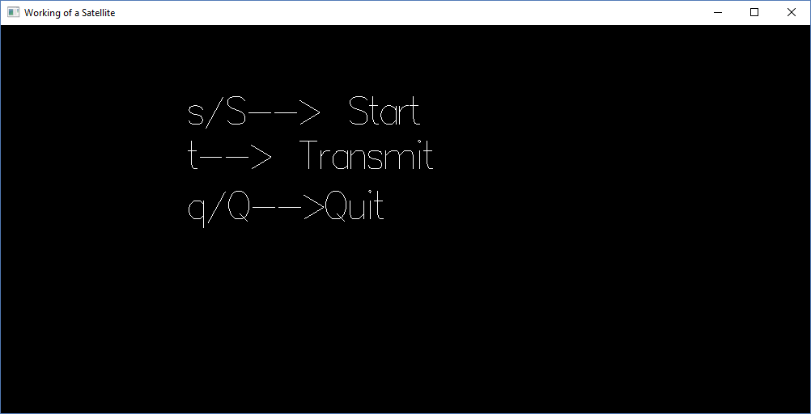

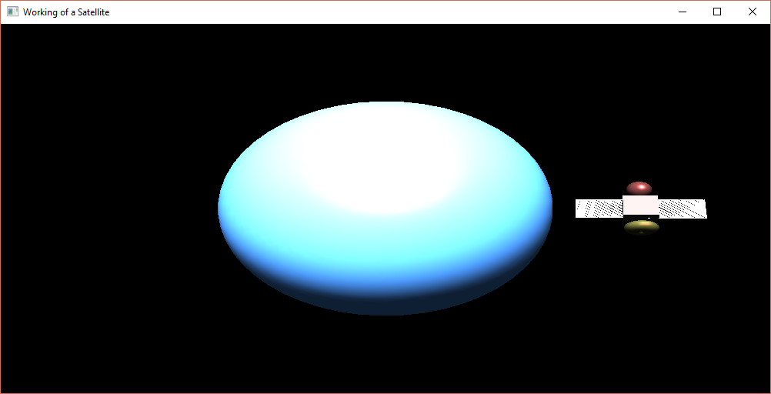

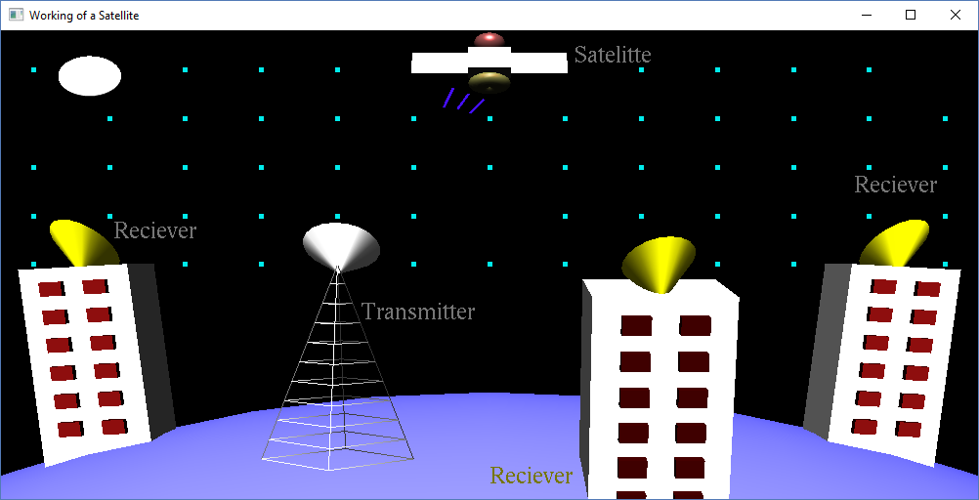

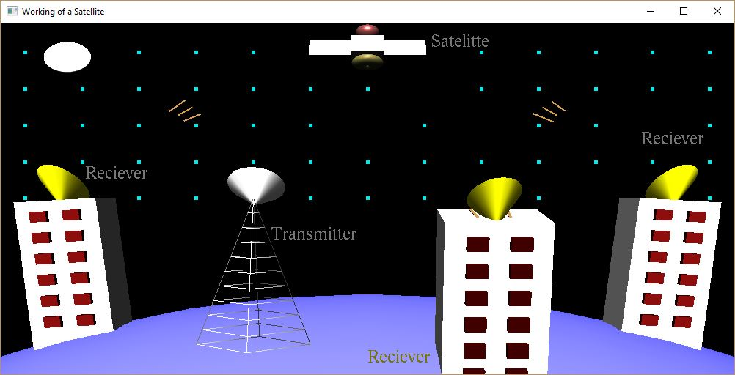

## *Conclusions*

The project “Working of a Satellite” demonstrates how signals are transmitted and received to and from a satellite.

Finally we conclude that this program clearly illustrate the working of a satellite using OpenGL and has been completed successfully and is ready to be demonstrated.

**Bibliography**

WE HAVE OBTAINED INFORMATION FROM MANY RESOURCES TO DESIGN AND IMPLEMENT OUR PROJECT SUCCESSIVELY. WE HAVE ACQUIRED MOST OF THE KNOWLEDGE FROM RELATED WEBSITES. THE FOLLOWING ARE SOME OF THE RESOURCES :

* TEXT BOOKS :

INTERACTIVE COMPUTER GRAPHICS A TOP-DOWN APPROACH

-By Edward Angel.

* COMPUTER GRAPHICS,PRINCIPLES & PRACTICES

- Foley van dam

- Feiner hughes

* WEB REFERENCES: <http://jerome.jouvie.free.fr/OpenGl/Lessons/Lesson3.php>

<http://google.com>

<http://opengl.org>